Running notebooks locally instruction set:

Table of Contents

Expected workflow: 1

Downloading the NeuroDot Py Library: 1

Downloading a notebook from OXI: 2

Running notebooks locally on your data 4

# Expected workflow:

This instruction set will go over how to download any of the pipeline’s notebook and run it locally on your machine. It will show you how to install obtain the necessary libraries from GitHub and how to run the cells.

# Downloading the NeuroDot Py Library:

1. Visit <https://github.com/WUSTL-ORL/NeuroDOT_py> and download the GitHub repository by clicking either clone or download zip

NOTE: You will need python and vs code, instructions on how to do this are in the OXI Upload instructions.

1. Once you have downloaded the files save/unzip in a location that you would like, this will be needed for the next steps for running the notebook locally.

# Downloading a notebook from OXI:

1. After running a container navigate to the manage files and download the notebook and corresponding data:

1

2

2

3

Clicking on link that arrow with label is pointing to:

1. Will download an individual file e.g. output.ipynb or any png
2. Will download the entire folder with its contents.
3. Will download all contents of the topmost scan folder “scans”

# Running notebooks locally on your data

1. Unzip the file and open the notebook in VS code
2. (1) Add the path to the NeuroDOT_Py library that you downloaded from [GitHub](https://github.com/WUSTL-ORL/NeuroDOT_py) and click shift+enter/return to update the stored values and run the cell
3. (2) Modify the highlighted lines to the correct path in your downloads folder and click shift+enter/return to update the stored values and run the cell

1

2

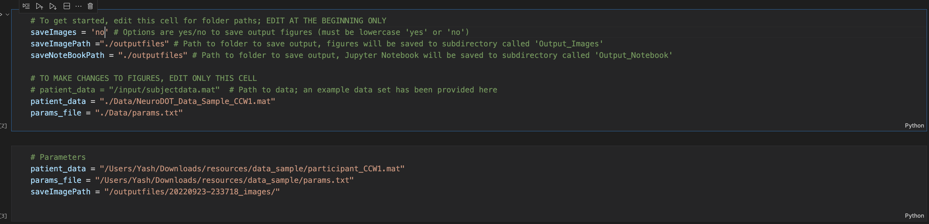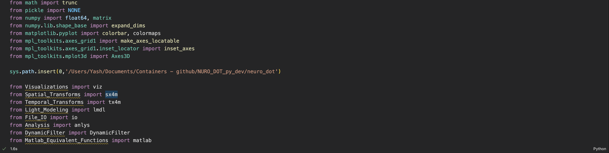

NOTE: At each point run the cell to update any paths or variables that are modified

1. After the above is finished, you can make any modifications you want i.e. modify the params file and view the results by rerunning the rest of the notebook.
2. You may have to modify "loadmat" to be "loadmat7p3" depending on the format of the data you are trying to load in the following cell. **“loadmat7p3” is used generally for very large mat files.**

1. In the example below the params file was modified using a new bthresh and the cell was rerun to view results:

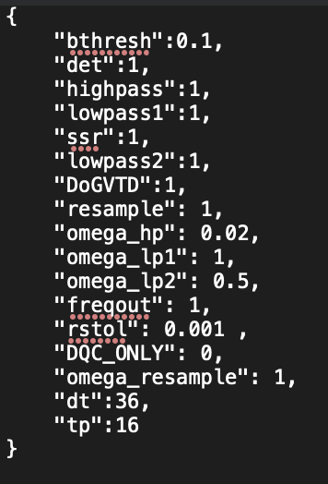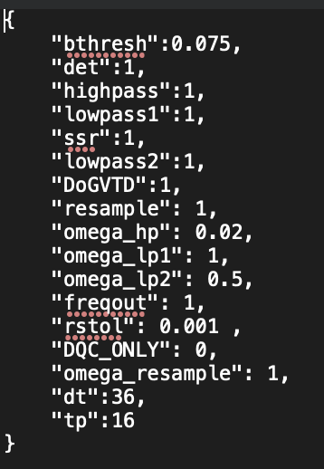

NOTE: Outside of modifying the entire params.txt for new params you can also add a new line after the params file is loaded and modify individual values

